FITTING A LINE TO THE DATA
Imagine we have some $(x;y)$ data points.
First, we draw a line that represents the mean of the data. $\overline{x}=3.5$
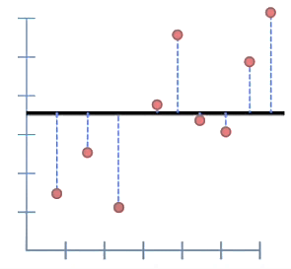
Then, we can calculate the total distance from the each datapoint to the line.
Or even better … we can calculate the sum of the square distance between the observed values and the line:
$$SSR=\sum_{i=1}^{n}{{\left(\overline{x}-y_{i}\right)}^{2}}=24,62$$
This SSR (sum of squared residuals) is our measure of how well this line fits the data.
Now, let´s see how good the fit is if we rotate the line a little bit…
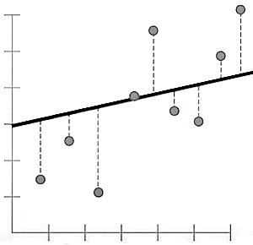
$$SSR=\sum_{i=1}^{n}{{\left(f\left(x_{i}\right)-y_{i}\right)}^{2}}=18,78$$
The SSR is lower than before, so this line fits the data better than the mean.
But is this the best fit we can find? NO!
If we keep rotating the line, we will get a lower SSR every time, but at certain point we will start getting a higher number than before … mm 🤔. So, if we plotted the sum of the squared residuals vs each rotation, we would get something like this:
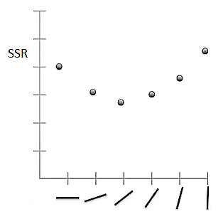
To find the equation for the line that is the best fit for our data (that minimizes SSR), we do the following …
1st, we write the generic line equation:
$$y=a x+b$$
where:
$$y:responde variable$$
$$x:predictor variable$$
$$a:slope$$
$$b:intercept$$
We want to find optimal values for parameters $a$ and $b$ so that we minimize the SSR, so we replace $f(x)=a x+b$ in SSR equation …
$$SSR=\sum_{i=1}^{n}{{\left(\underset{\begin{aligned}value of the \\ line at x_{i}\end{aligned}}{\underbrace{a x_{i}+b}}-\underset{\begin{aligned}observed \\ value\end{aligned}}{\underbrace{y_{i}}}\right)}^{2}}$$
2nd, we take the derivatives of SSR for both the slope and intercept and find where they are equal to zero:
$$\left\{\begin{aligned}\frac{∂ SSR}{∂ a}=0 \\ \frac{∂ SSR}{∂ b}=0\end{aligned}→a^{*}=0,77; b^{*}=0,66\right.$$
3rd, we replace the optimal parameters in the generic line equation…
$$y=0,77x+0,66$$
NOTE: Since we want to find the line that will give us the smallest sum of squares, this method for finding the best values for $a$ and $b$ id called LEAST SQUARES.

